Python Internship Tasks Report
Name: Niveditha
Course: B.Tech CSE
Domain: Python Development Internship
Task 3
Data Analysis using Pandas
Objective
To analyze and process data using Pandas.
Dataset
CSV file with student marks.
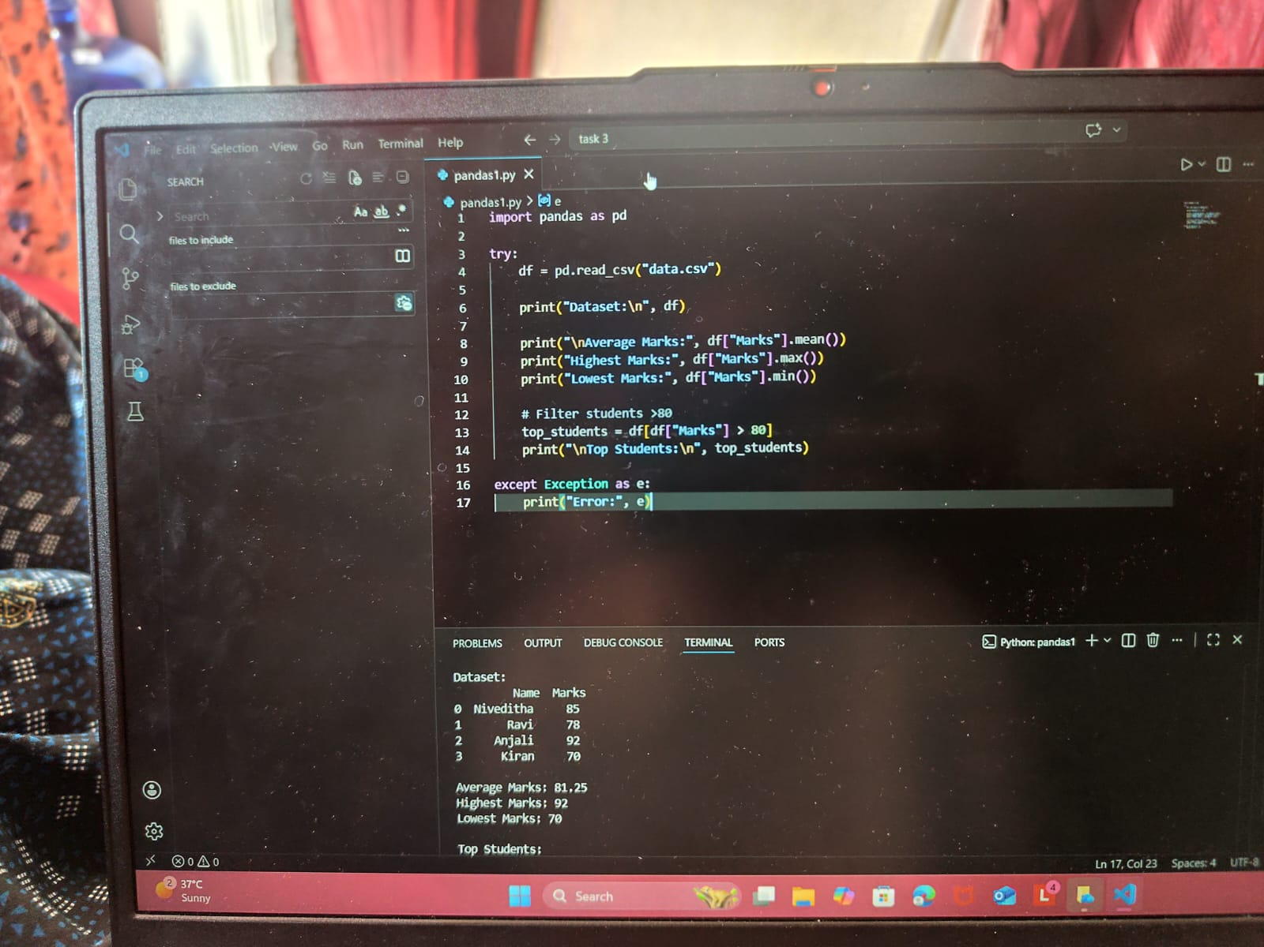
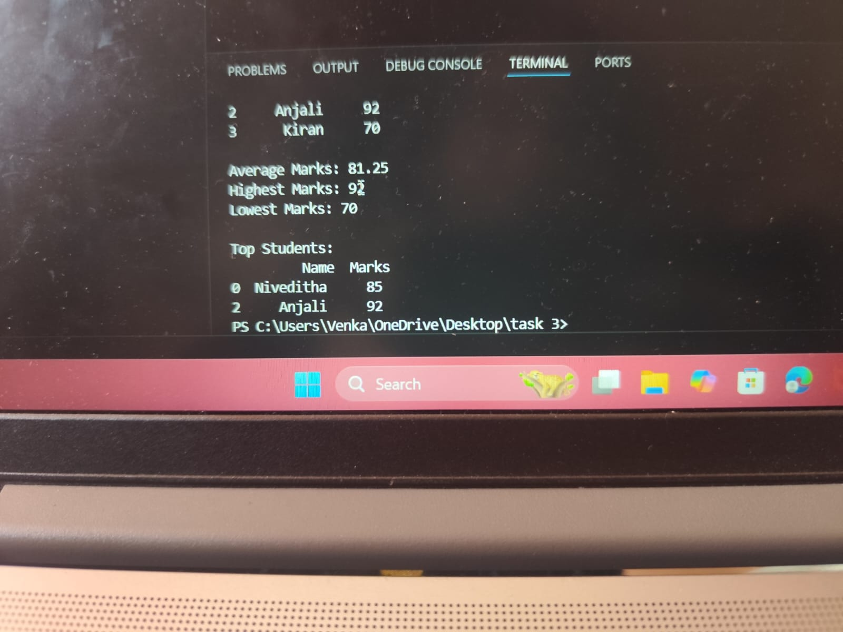

Output
- Displayed dataset
- Calculated average marks
- Filtered top students

Conclusion
This internship helped me understand:
- File handling automation
- API integration
- Data analysis using Pandas

